1. Create on Bash script to check if a directory is available or not.

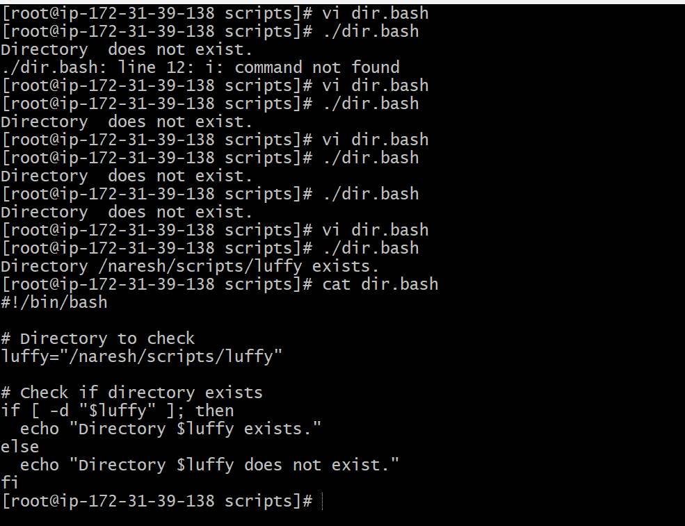

1. Create a bash script which will create multiple files.

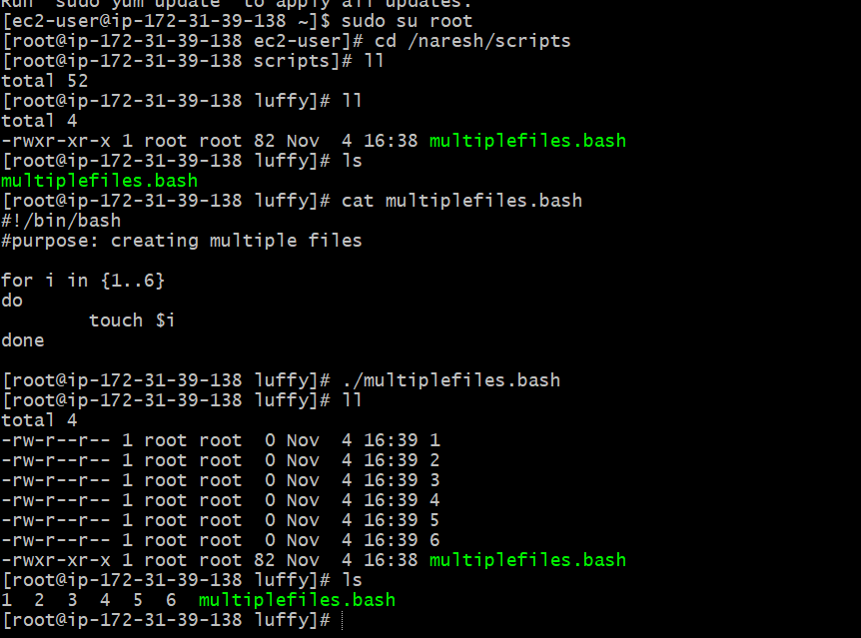

1. Create a bash script to take backup of a directory.

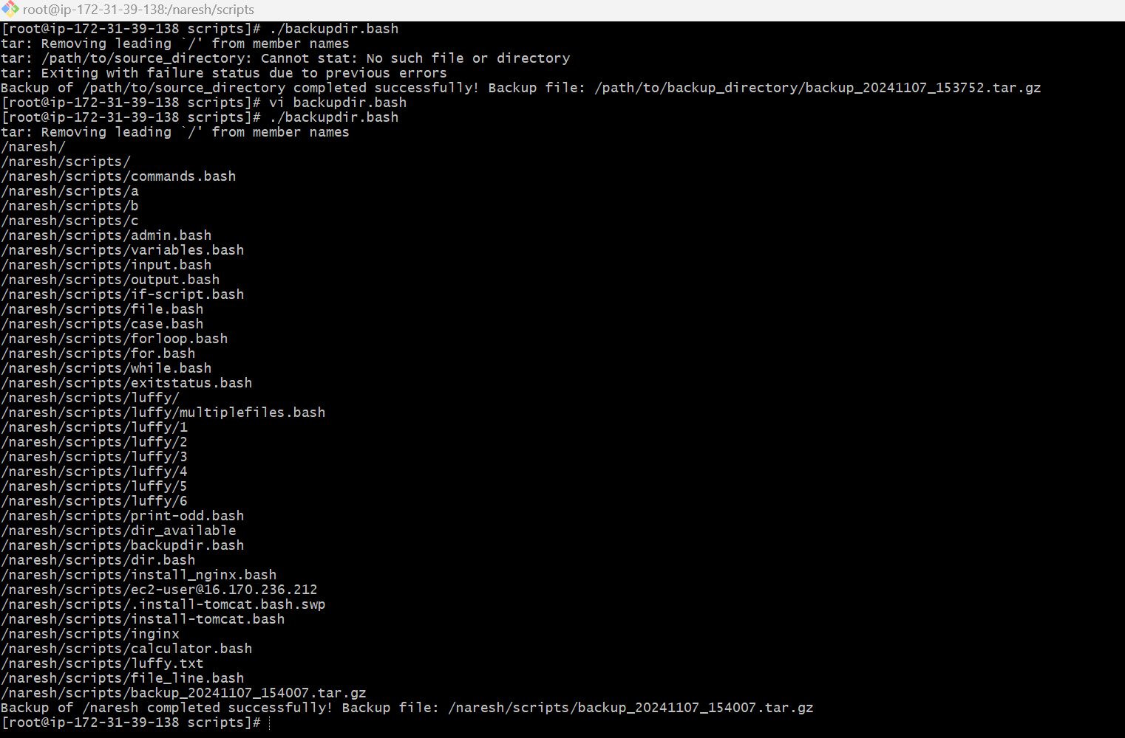

1. Create a bash script to install nginx in ec2 server.

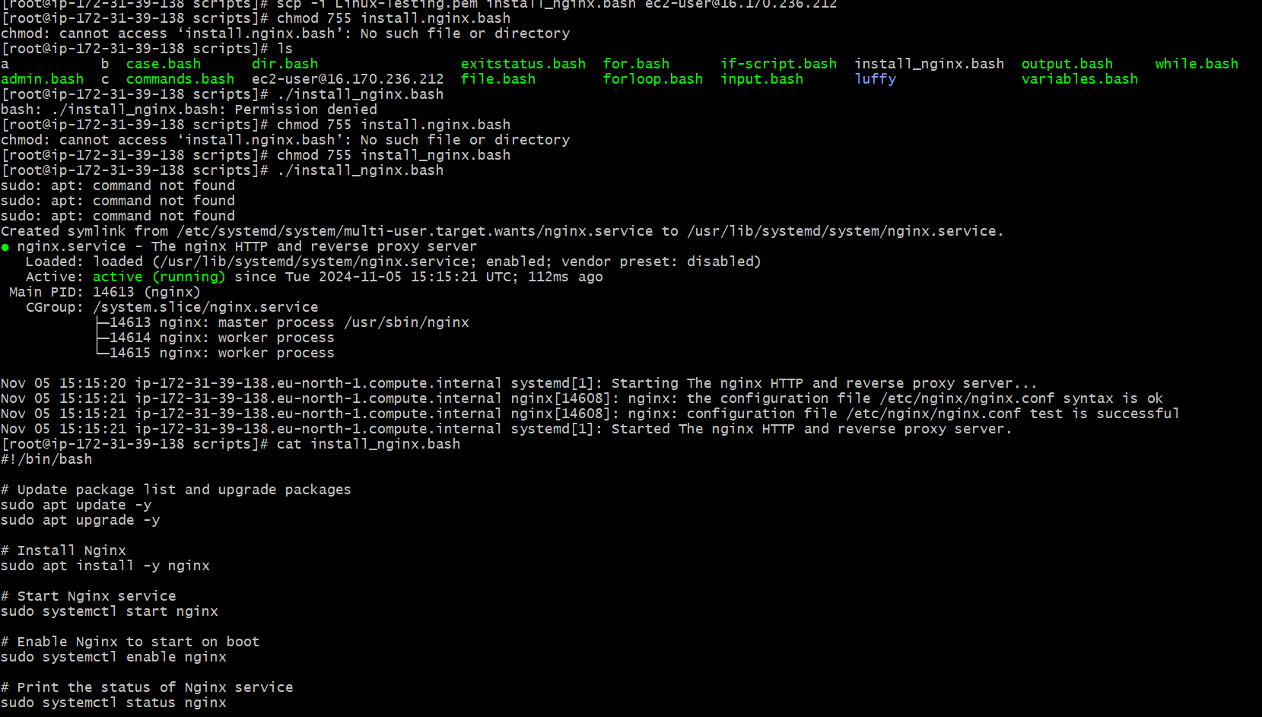

1. Create a bash script to install ApacheTomcat in ec2 server

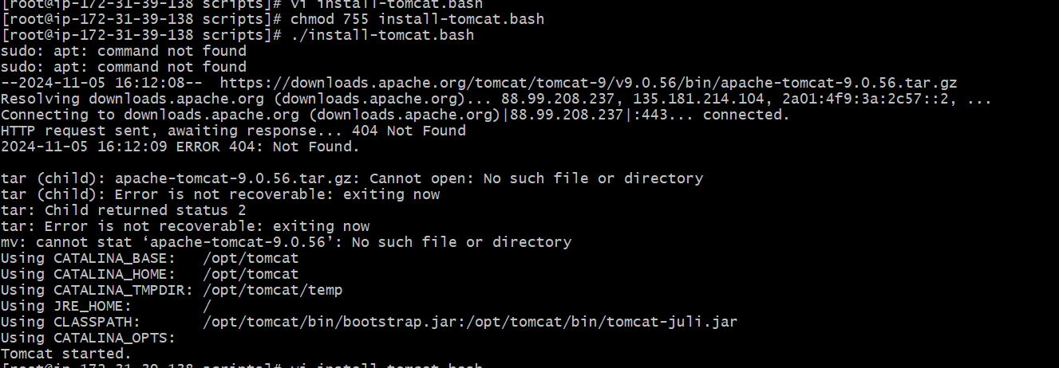

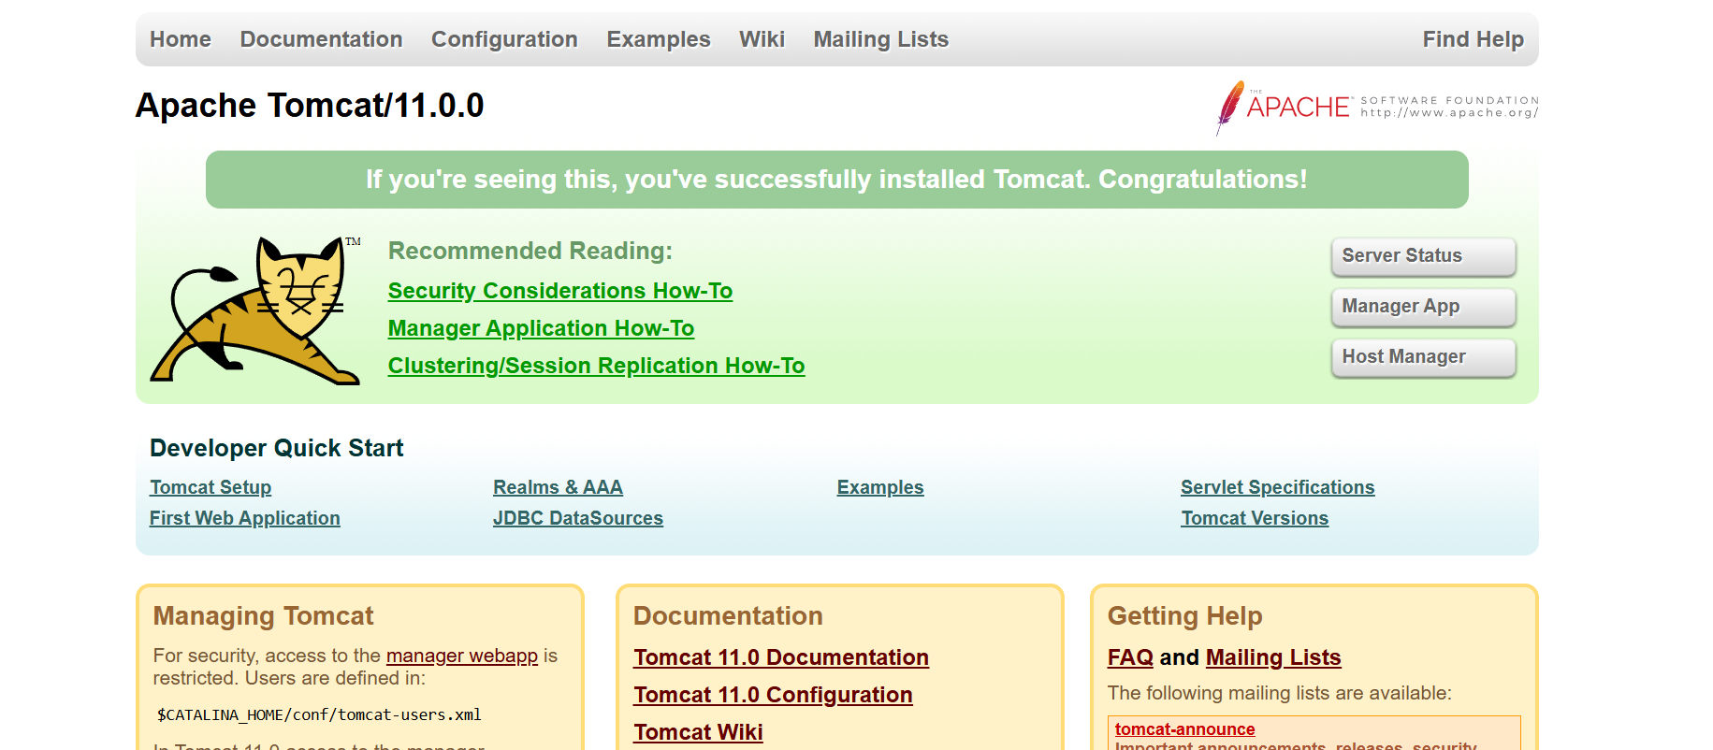

1. Create a bash script to check list if nginx service is running or not,if not running then script should start the service.

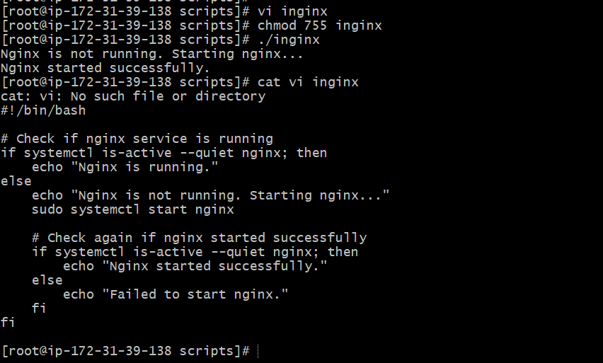

7.Create a bash script for calculator.

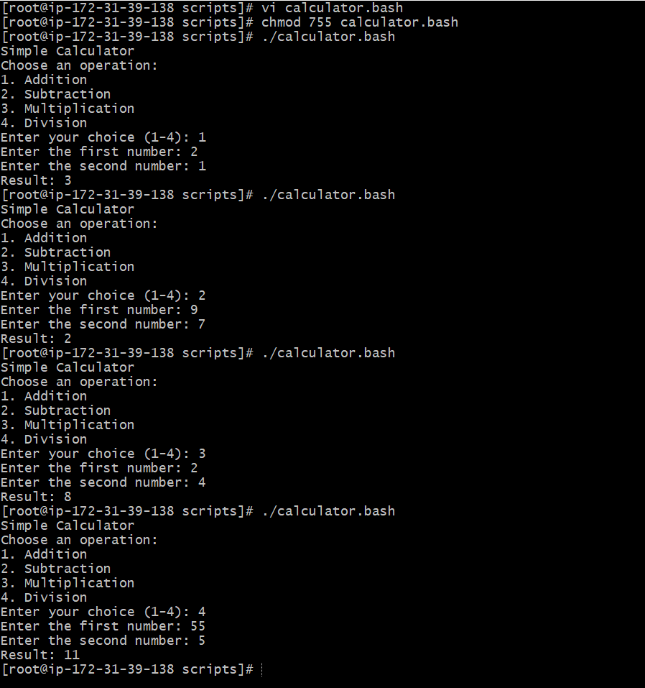

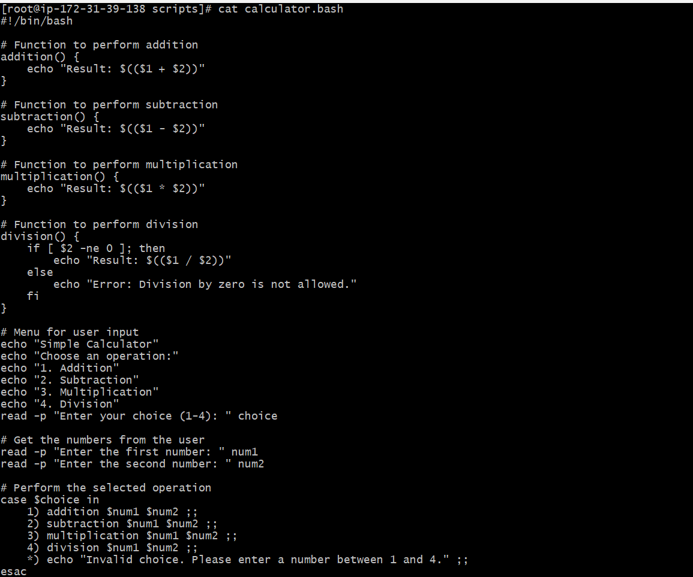

8.Create a bash script to check if directory is avaialble or not,if not then create a directory.

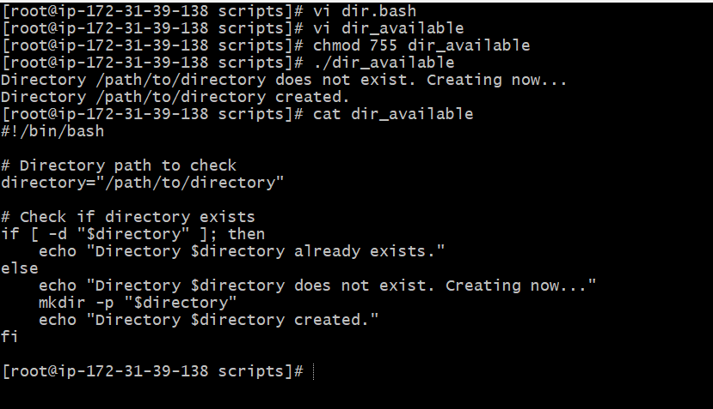

9.Create bash script to delete last 3 lines for a file.

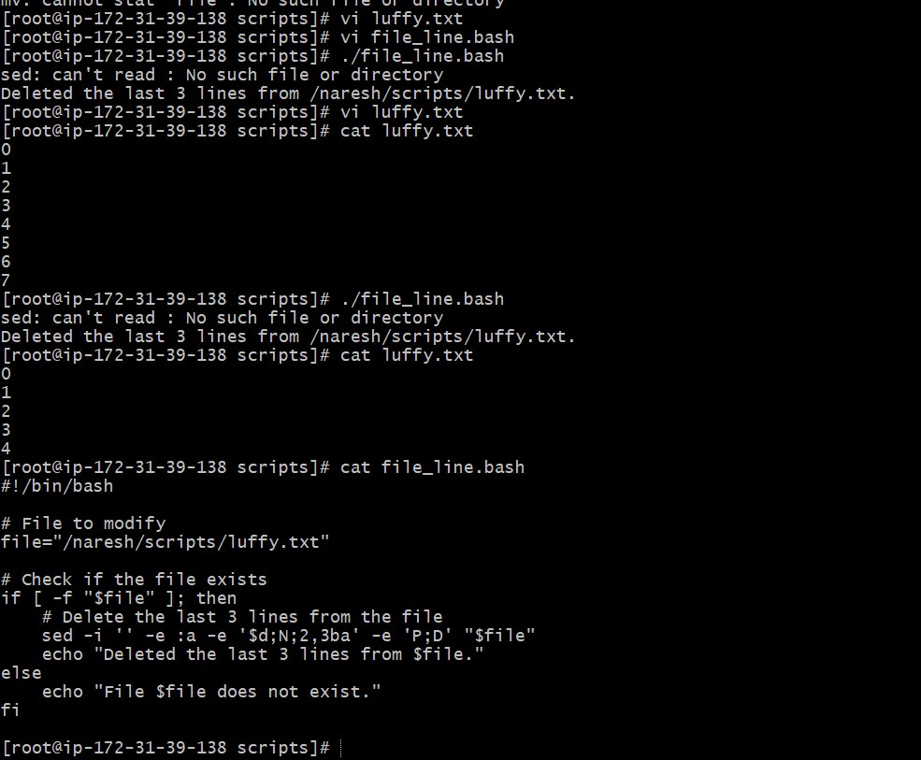

Exercise Crontab Entries :

1. April 5th Midnight

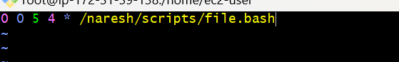

2) 5 th of Every November,Jan,June if it is a Thursday.

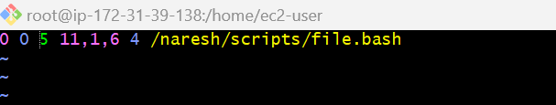

3) At 05 and 27th minutes of 9,10,11 hours everyday.

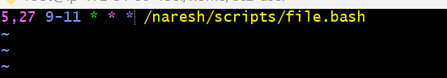

4) 34 min. of 9th hour on 15th Aug.

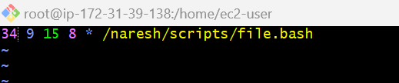

5) Every midnight

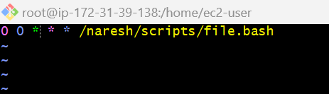

6) Every Weekend ( Saturday night 11.59 ) 7) After every reboot

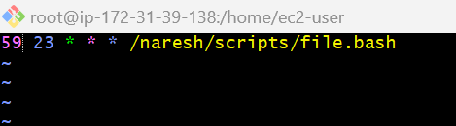

7.After every reboot

